Who will do this work?
Q1. If nobody cleared the garbage lying outside your school or your house for one week, then what would happen?
If nobody would cleared the garbage lying outside our school or our house , there would be –
- a lot of garbage accumulated here and there on the roads.
- The place would became very filthy and foul smelling.
- A lot of mosquitoes and other germs would breed in these areas and spread diseases.
Q2. The use and maintenance of cleaning tools are essential to providing a safe and clean environment. Name some cleaning tools with their uses.

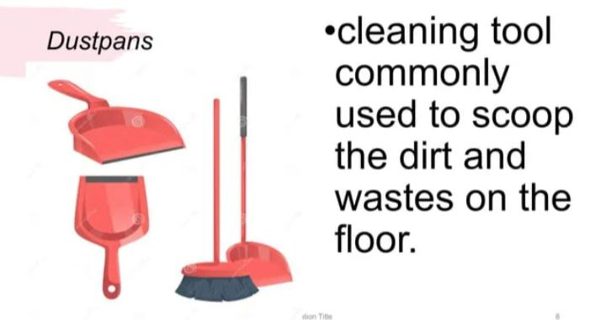
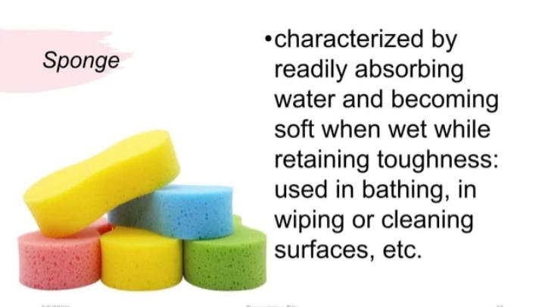

Q3. Gandhiji and his team start doing the job of cleaning? What do you think about this?
Ans. Gandhiji and his team started doing the job of cleaning so that people should come out of their mindset. He wanted people to respect every type of job. He wanted that people should understand that a particular job is not meant only for a particular caste
Q4.Answer the following questions based on Gandhiji's work against untouchability.
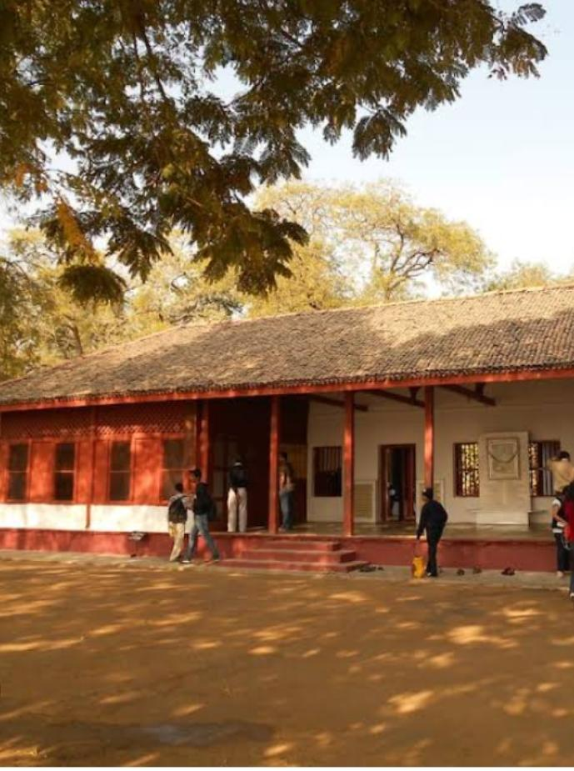

(Ans by own)
(i) What was the name of Gandhiji's Ashram at Ahmedabad?
______________________________________________________
(ii) Who was Narayan? What was his job in the Ashram?
______________________________________________________
(iii) Who did the cleaning work in Gandhiji's Ashram?
________________________________________

